

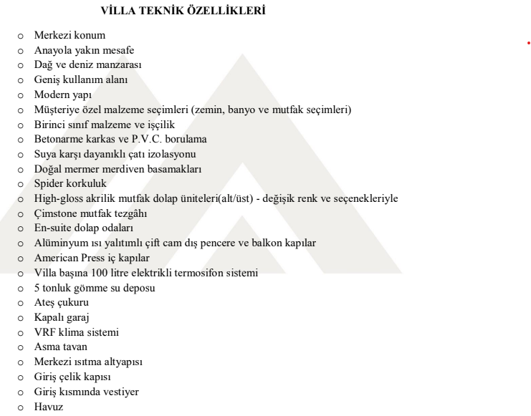




info@kesperinvestment.com +90 542 859 1905 Karşıyaka Sokak, 191 Apt.

www.kesperinvestment.com
+90 533 872 1903
No:6, Girne/ KKTC

